Bug Box Assembly Guide:

Collect the Following Components:

Component ID | Item: | Quantity:
1 | 18650 | 2
2 | XIAO-ESP32S3-Plus + Antenna | 1
3 | 2515 Rocker Switch | 1
4 | L3705N Mosfet | 1
5 | Transistor Heat Sink | 1
6 | Heat Sink mounting screw and spacer | 1
7 | 220 Ohm Resistor | 1
8 | Nickel Strip 43mm Length | 2
9 | M3 Heat Set Inserts | 4
10 | Rubber Gromet | 1
11 | Female Brass Spade Connector | 2
12 | 3D Printed Enclosure Body | 1
13 | 3D Printed Mounting Block | 1
14 | 3D Printed enclosure top | 1
15 | 20 AWG Black Wire | 1
16 | 20 AWG Blue Wire | 1
17 | 26 AWG Orange Wire | 1
18 | 26 AWG Red Wire | 1
19 | 26 AWG Black Wire | 1
20 | Two Part Epoxy | 1
21 | Solder | 1
22 | Kapton Tape | 1
23 | M3 Screw 5mm | 4

Collect the following tools:
Item:
Spot Welder
Soldering Iron
Side Cutters
Calipers
Wire Strippers

Bug Box Assembly Guide:

- Solder 26AWG Red Wire (65mm) to the edge of Nickel strip 43mm length, and Solder 26AWG Black Wire (43mm) to the edge of Nickel strip 43mm length
- grab the two 18650 cells and place them in the 3D Printed Spot Welding Jig.
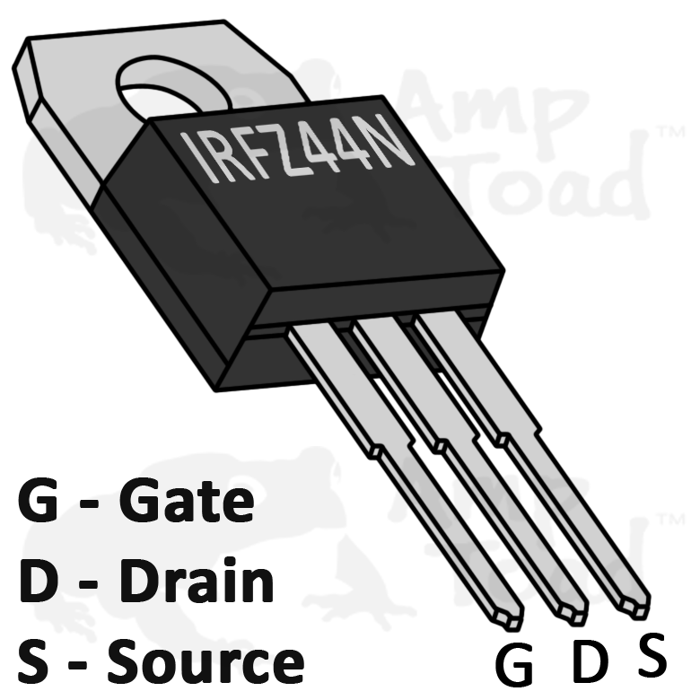
- Turn on spot welder, place the nickel strip on both cells so it is in contact, and so that one edge is lined up with the end of a radius. Ensure that the color wire corresponds to the polarity (+ >> Red Wire 65mm) (- >> Black Wire 60mm) both wires
- Spot weld one side, then fold the extended tab inwards so that it is now perpendicular to the opposing nickel strip.
- Do steps 3 and 4 to both sides of the cells.
- Wrap battery pack in Kapton Tape until properly electrically insulated
- Place battery pack in the 3D printed enclosure body so the wires are on the topside, and pointing the direction of the USB-C port. Hot glue a small line to place the cells on top of for a secure fit.
- Solder 26AWG Orange wire 53mm to the gate pin of the Mosfet
- Solder 20AWG Blue wire 215mm to the drain pin of the Mosfet
- Solder 20AWG Black wire 215mm and 26AWG Black wire (50mm) and to the source pin of Mosfet
- Fasten heat sink to Mosfet with mounting hardware
- Solder the 220 Ohm Resistor to pin D3 on the Xiao ESP32S3 Plus and then solder the remaining lead of the resistor to the 26AWG Orange wire
- Solder the other end of the 26AWG Black wire to the GND pin of the Xiao ESP32S3 Plus
- Solder the Black 26AWG that was previously attached to the 18650 Cells, and solder it to the battery - pad of the Xiao ESP32S3 Plus.
- Solder the Red 26 AWG that was previously attached to the 18650 Cells, and solder it to one of the two female brass spade connectors.
- Solder 26AWG Red wire 60mm to the other female brass spade connector, then solder that same wire to the battery + pad of the Xiao ESP32S3 Plus. Heat shrink both connectors to ensure protection against shorting. Make sure that these wires are going through the rectangular cavity for the switch prior to soldering so that it can be fit into place afterwards.
- Begin mixing two-part epoxy on a sheet of disposable cardboard or paper
- Apply epoxy to the back of the Xiao ESP32S3 Plus and press fit into its designated cavity. Keep in mind the placement of wires and that the wires going to the BATT+ and BATT- pads can be lined underneath the board to ensure a flush surface mount.
- Press fit antenna onto Xiao ESP32S3 Plus
- After gluing the Xiao ESP32S3 Plus, press the assembled Mosfet into the cut out with tabs on either side. Make sure that the middle fin sets into the ridge of the heat sink, so the bottom surface of the heat sink is flush with that of the 3D printed enclosure body. Put small drops of epoxy into the corners of the heat sink so that it touches both the heat sink and the 3D printed enclosure body.
- Take the rubber gromet and press it into the circular cutout on the 3D printed enclosure body. Feed the Blue and Black 20AWG wires out of the gromet.
- Take the four heat set inserts you have collected earlier, press fit them with the soldering iron into all four mounting points of the 3D printed enclosure body.
- After all glue is at least partially hardened, switch on the rocker switch. You should see a light from the Xiao ESP32S3 Plus. If you do not see it, check for any shorts or inconsistent soldering joints.
- Grab the 3D printed top plate and fasten it with 4 M3 5mm screws.

